SOFTWARE TESTING REPORT
Faculty Management System – Faculty Review and Registration Module
Module Name: Faculty Management System – Faculty Review and Registration Module
Test Case IDs: TC_001–TC_005
Website URL:
Scenario ID: TC_001
Scenario: Verify that faculty details are correctly documented and reviewed
Test Steps:
- 1. Open the faculty requirement Site
- 2. Check faculty name and ID
- 3. Verify department information
- 4. Identify missing or incorrect details
- 5. Record review findings
Test Input: Faculty Name: Chirag Patel
Faculty ID: F101
Department in document: IT; reference department: Computer Science
Expected Result: Missing or incorrect faculty details are identified and recorded.
Actual Result: Faculty details reviewed and findings documented.
Status: Pass
Screenshot:
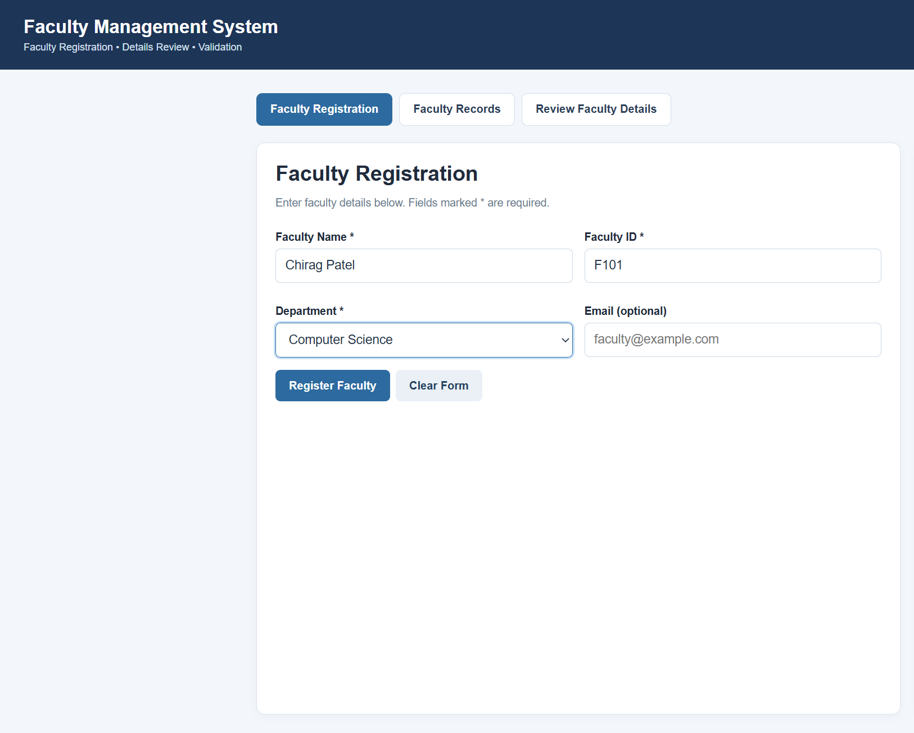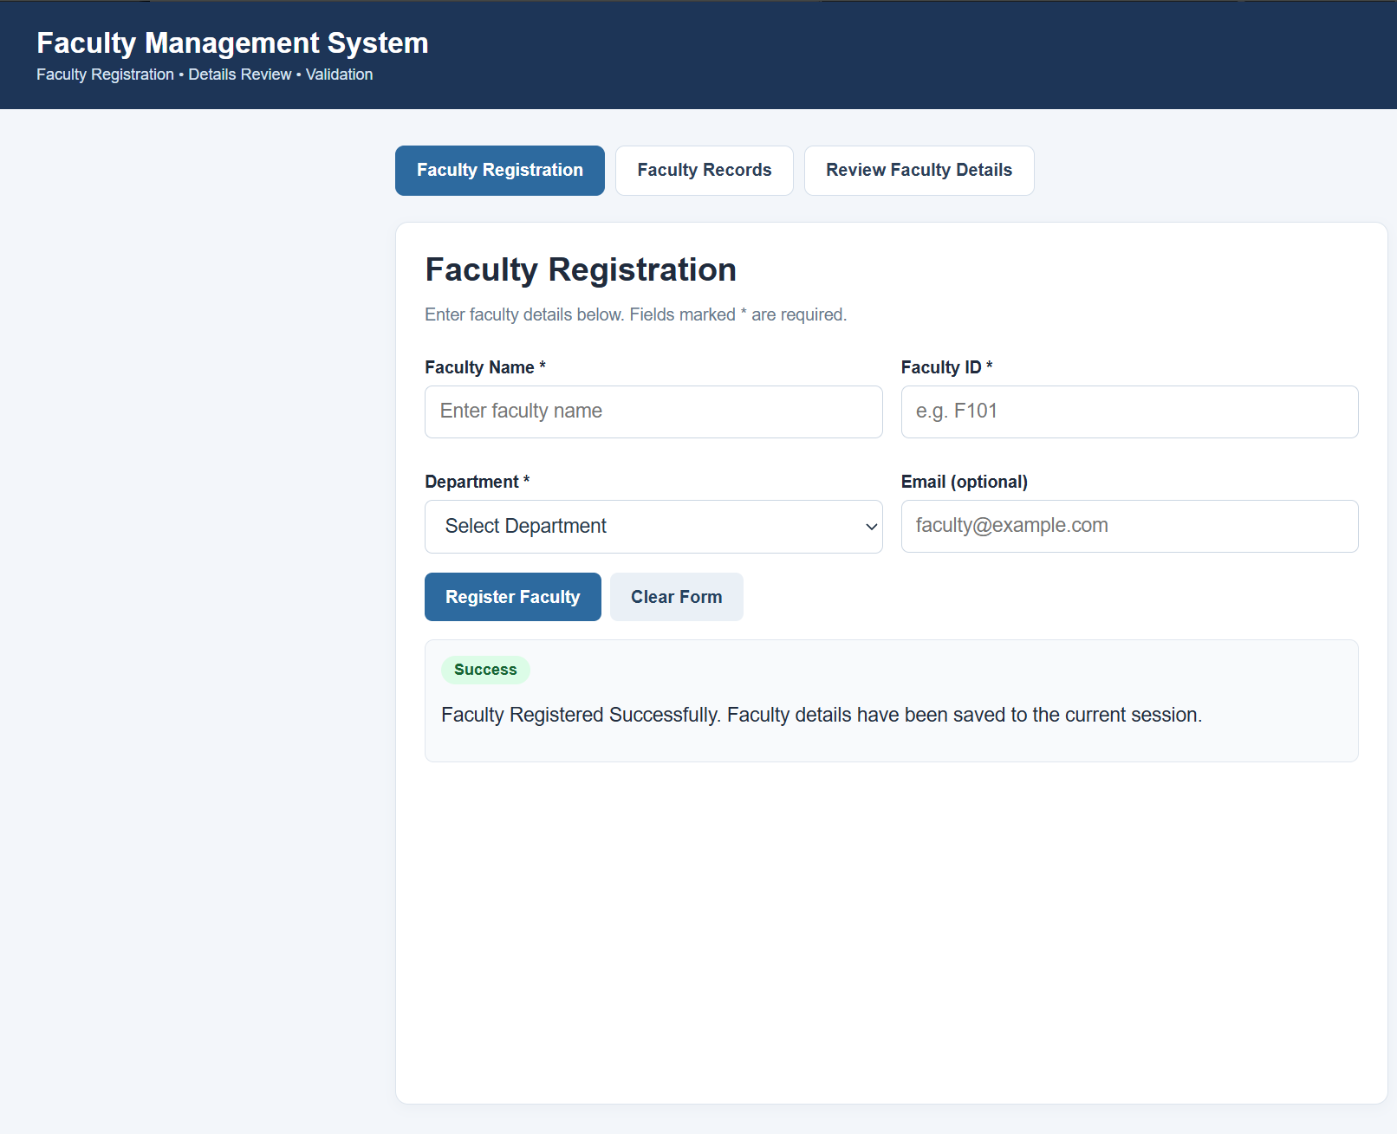
Scenario ID: TC_002
Scenario: Verify that missing faculty details are identified
Test Steps:
- 1. Open the faculty document
- 2. Check faculty name
- 3. Check Faculty ID
- 4. Verify department
- 5. Record the missing information
Test Input: Faculty Name: Amit Singh
Faculty ID: Blank
Department: Computer Science
Expected Result: Missing Faculty ID is identified and recorded for correction.
Actual Result: Missing Faculty ID identified and recorded.
Status: Pass
Screenshot:
Paste screenshot for this scenario here
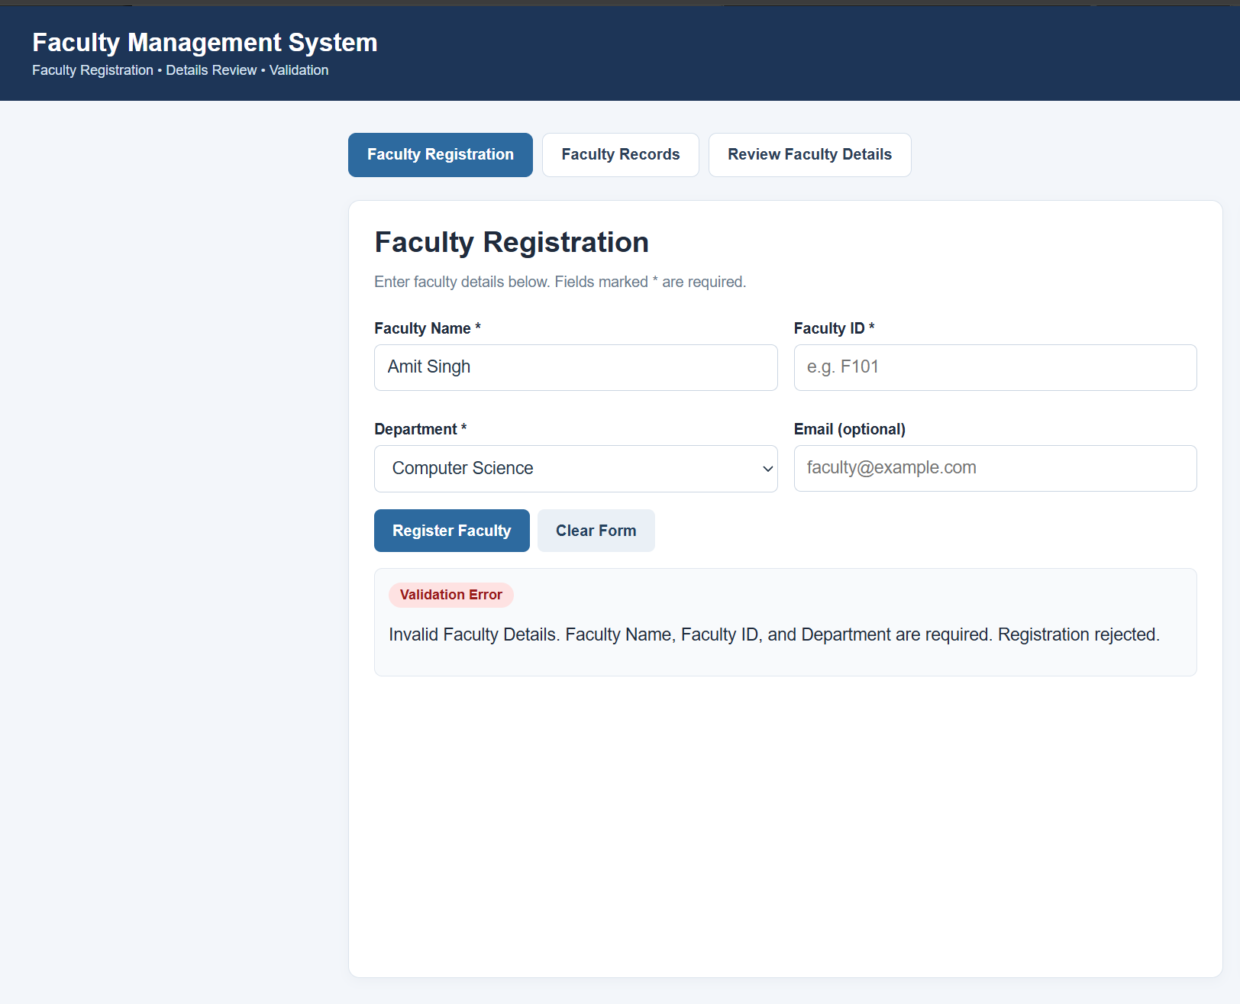

Scenario ID: TC_003
Scenario: Verify that incorrect faculty information is identified
Test Steps:
- 1. Open the faculty document
- 2. Check Faculty ID F103
- 3. Compare department details
- 4. Verify the reference information
- 5. Record the error
Test Input: Faculty ID: F103
Department in document: IT
Reference department: Computer Science
Expected Result: The department mismatch is identified and recorded.
Actual Result: Department mismatch identified and recorded.
Status: Pass
Comments: Record the mismatch and mark the document for correction.
Screenshot:
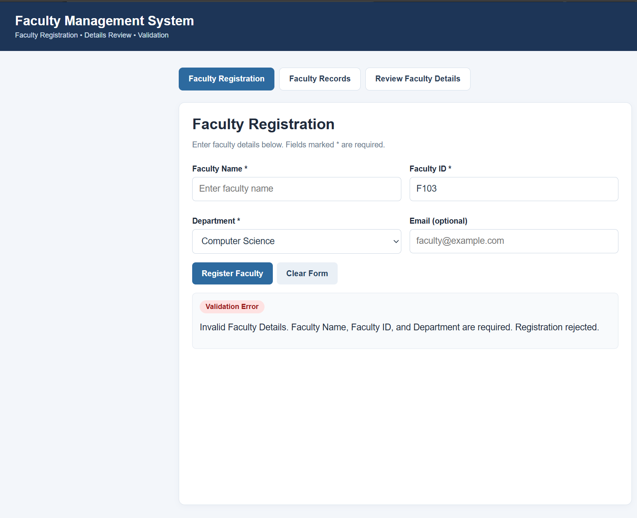

Scenario ID: TC_004
Scenario: Verify that the reviewed faculty document is ready for approval
Test Steps:
- 1. Open the reviewed faculty document
- 2. Check faculty details
- 3. Check review findings
- 4. Verify corrections
- 5. Check document completeness
Test Input: Faculty Name: Neha Patel
Faculty ID: F104
Department: IT
Expected Result: The reviewed document is complete and ready for approval.
Actual Result: Document reviewed and prepared for approval.
Status: Pass
Screenshot:
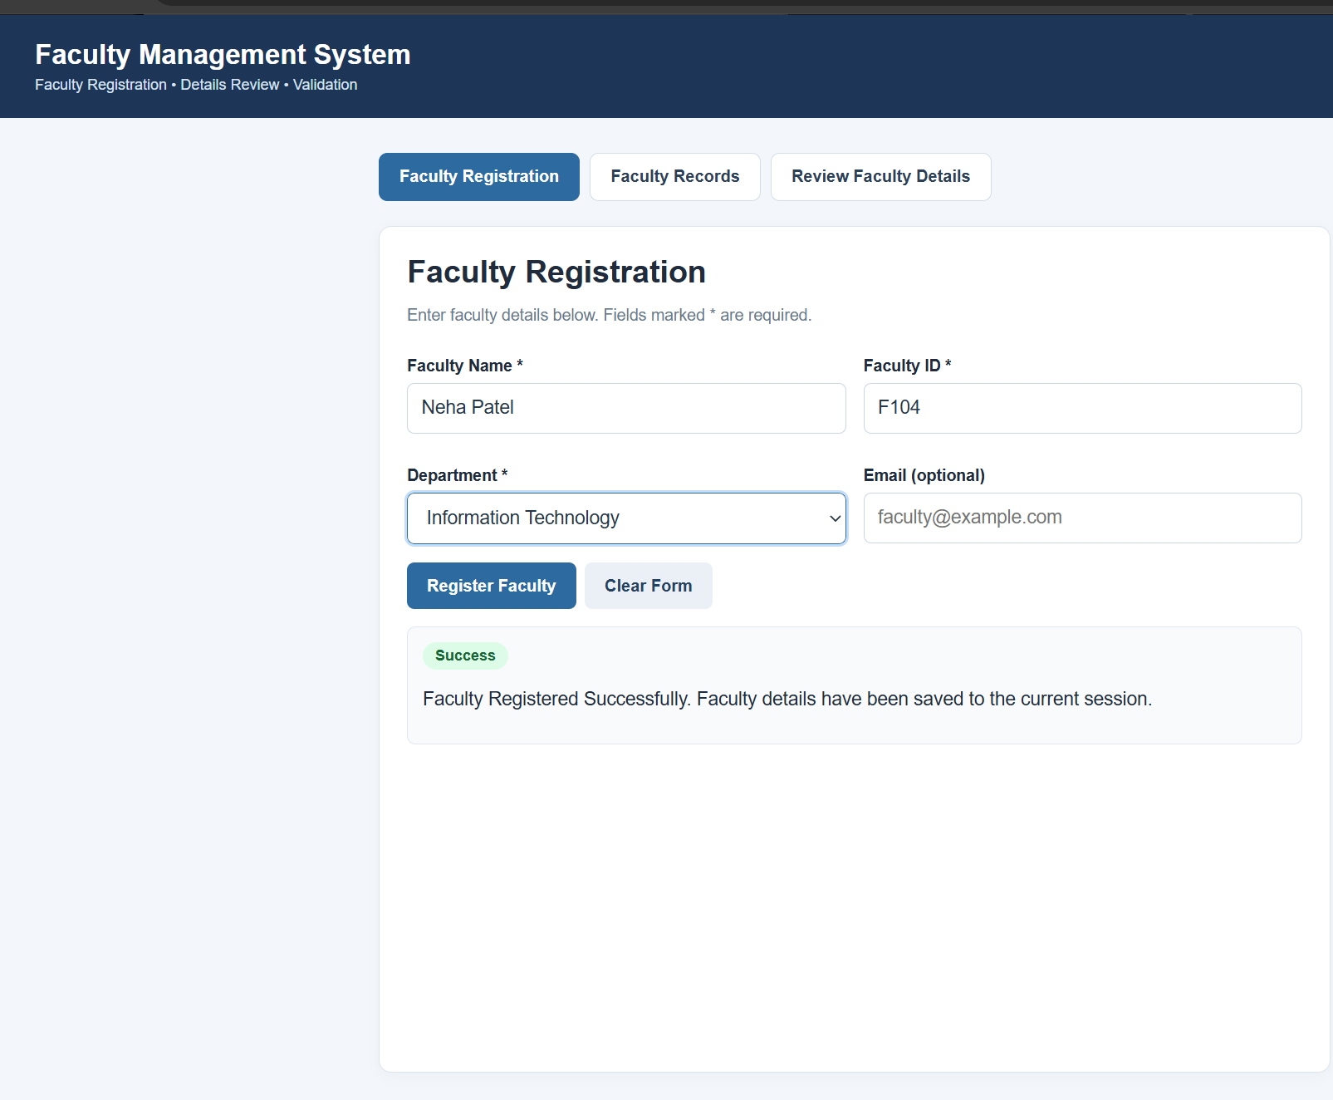

Scenario ID: TC_005
Scenario: Verify that faculty registration is rejected when the department is empty
Test Steps:
- 1. Run the faculty registration test lab
- 2. Enter faculty name
- 3. Enter Faculty ID
- 4. Leave department empty
- 5. Submit registration and check the result
Test Input: Faculty Name: Chirag Patel
Faculty ID: F105
Department: Blank
Expected Result: “Invalid Faculty Details” is displayed and registration is rejected.
Actual Result: “Invalid Faculty Details” displayed; registration rejected.
Status: Pass
Comments: The empty department should trigger validation. Insert your actual execution screenshot below.
Screenshot:
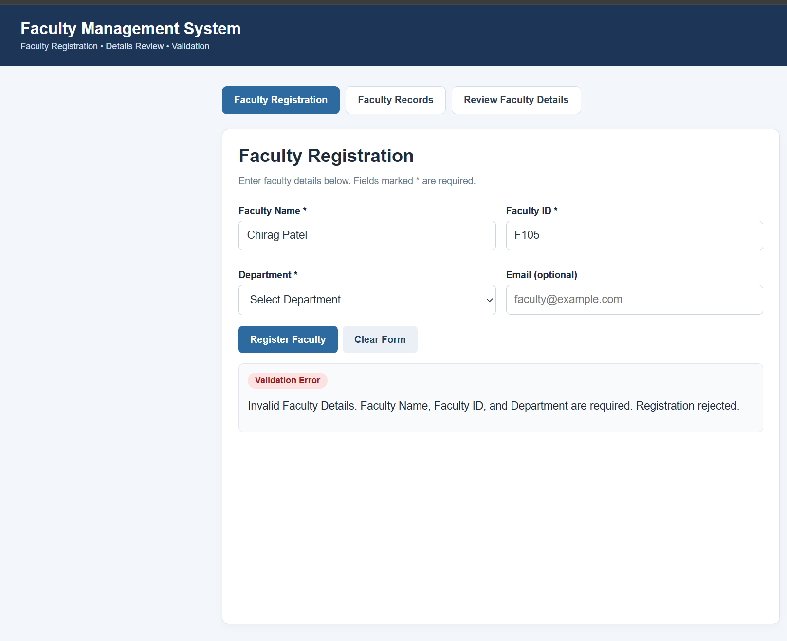

Summary of Test Results
Metric | Result
Total Test Scenarios | 5
Passed | 5
Failed | 0
Pass Percentage | 100%

Conclusion and Recommendations
This report covers five Faculty Management System test scenarios: faculty details review, missing information review, incorrect information verification, document approval readiness, and rejection of registration when the department is empty. The prepared scenario results show all five cases as Pass; confirm and update them based on your actual execution before submitting.
Recommendation: Maintain required-field validation for faculty registration, ensure missing or incorrect faculty information is recorded for correction, verify all review findings before approval, and display a clear validation message when the department field is left empty. Insert the corresponding screenshots before final submission.

